A
MINI PROJECT
ON
QUIZ GAME
COMPUTER SCIENCE & ENGINEERING
Submitted by
MS. RITU DUBAY (1901610100159)
MR. TALIB KHAN (1901610100214)
MR. ARPIT KUMAR DHURIYA (1901610100032)
Guided By
Miss. SHIPRA GAUTAM
Assistant Professor
Computer Science and Engineering Department


DEPARTMENT OF COMPUTER SCIENCE ENGINEERING
KRISHNA ENGINEERING COLLEGE
GHAZIABAD
2020-2021
Acknowledgement

I take this opportunity to express my deep gratitude and most sincere thanks to my project mentor, MISS. Shipra Gautam for giving most valuable suggestion, helpful guidance and encouragement in the execution of this project work.
I would like to thank my mentor for guiding us. Last But not the least we are grateful to having all the team members of project.

Prof. Miss. Shipra Gautam
Assistant Professor
DEPARTMENT OF COMPUTER SCIENCE ENGINEERING

Though perseverance and enthusiasm combined with effort in the right direction can bring forth the thing called success. But the realization of the harsh reality that the path towards success is full of my riads, temptations, impediments and pitfalls often proves to be disheartening in such situation, it is the able guidance of knowledgeable person that steers one through difficulties and help him achieve success.

I am highly obliged to express our deep sense of gratitude and grateful thanks to my erudite guide Prof. Shipra Gautam for her valuable guidance and support which led to the successful and timely completion of my seminar report.
I am secondly very thankful to our H.O.D, Dept. of Computer Science for his valuable suggestions & guidance.

Last but not the least, I deeply appreciate the cheerful encouragement of all staff members of my department and my friends.
INDEX

  - INTRODUCTION:
  - ABSTRACT:
  - MODEL OF THE PROJECT:
*DATA FLOW DIAGRAM:
  - CODING:
  - OUTPUT OF CODING:
  - REQUIREMENTS:
*HARDWARE REQUIREMENT:
*SOFTWARE REQUIREMENT:
  - TECHNOLOGY USED:
  - SCOPE OF THE PROJECT:
  - CONCLUSION:
  - REFERENCES:

General Introduction

I have divided this mini project into many functions, and listed below are some of those which may help you understand the project better.

edit_score() – adds the current cash prize won to the previous one upon giving the right answer to a question

help () – help menu with game summary and rules

reset_score() – to reset the highest score/cash prize to default

show_record() – shows the highest cash prize won by a particular user

show_score() – to view the highest score

In this quiz game mini project, you can store the user name, view the highest score secured by a user, and even reset the score. Additionally, to make the game look a little more interesting, it is divided into two rounds; user must pass the first round to reach the second one.

Of the 2 rounds I mentioned above, the first is called the Warm-up Round; the second is the Challenge round. In the warm-up round, the user is asked a total of three simple questions and they must be able to answer at least two of them correctly to enter the next round. If the user is not capable of doing that, he is not permitted to proceed further.

In the second and more interesting round of this quiz game in C, the user will be asked questions continuously, and for each right answer given, they will earn $100,000!

The game ends when the user’s cash prize piles up to $1 million. For each question asked, there are 4 options, namely A, B, C and D. There

are no negative markings, so the user’s accumulated cash money won’t be deducted for wrong answers to the questions.

ABSTRACT

The sole intention behind the consideration of this Project is to generate and manage a simple database for question.
This project is developed considering “QUIZ” information keeping context of the customer in mind.
Here, data is stored in a binary file by “QUESTION” and this database is basically used as MASTER file. Reports are designed on the basis of customer’s stay and payments made by the customer.

DATA FLOW DIAGRAM
QUIZ
GAME
GAME

PLAY
ADD QUESTIONS
EDIT

D.B.M.S
General
SCIENCE
GENERAL Awareness
Awareness of
DELETE
MODIFY
RETURN

Coding
#include<stdio.h>
#include<conio.h>
#include<ctype.h>
#include<stdlib.h>
#include<string.h>
void show_record();
void reset_score();
void help();
void edit_score(float , char []);
int main()
{
int countr,r,r1,count,i,n;
float score;
char choice;
char playername[20];
mainhome:
system("cls");
printf("\t\t\tC PROGRAM QUIZ GAME\n");
printf("\n\t\t______________");

printf("\n\t\t\t WELCOME ");
printf("\n\t\t\t to ");
printf("\n\t\t\t THE GAME ");
printf("\n\t\t______________");
printf("\n\t\t______________");
printf("\n\t\t BECOME A MILLIONAIRE!!!!!!!!!!! ") ;
printf("\n\t\t______________");
printf("\n\t\t______________");
printf("\n\t\t > Press S to start the game");
printf("\n\t\t > Press V to view the highest score ");
printf("\n\t\t > Press R to reset score");
printf("\n\t\t > press H for help ");
printf("\n\t\t > press Q to quit ");
printf("\n\t\t______________\n\n");
choice=toupper(getch());
if (choice=='V')
{
show_record();
goto mainhome;
}
else if (choice=='H')
{
help();getch();
goto mainhome;
}
else if (choice=='R')
{reset_score();
getch();
goto mainhome;}
else if (choice=='Q')
exit(1);
else if(choice=='S')
{
system("cls");

printf("\n\n\n\n\n\n\n\n\n\n\t\t\tResister your name:");
gets(playername);

system("cls");
printf("\n ------------------ Welcome %s to C Program Quiz Game --------------------------",playername);
printf("\n\n Here are some tips you can know before playing:");
printf("\n -------------------------------------------------------------------------");
printf("\n >> There are 2 rounds in this Quiz Game,WARMUP ROUND & CHALLANGE ROUND");
printf("\n >> In warmup round you will be asked a total of 3 questions to test your");
printf("\n general knowledge. You are eligible to play the game if you give atleast 2");
printf("\n right answers, otherwise you can't proceed further to the Challenge Round.");
printf("\n >> Your game starts with CHALLANGE ROUND. In this round you will be asked a");
printf("\n total of 10 questions. Each right answer will be awarded $100,000!");
printf("\n By this way you can win upto ONE MILLION cash prize!!!!!..........");
printf("\n >> You will be given 4 options and you have to press A, B ,C or D for the");
printf("\n right option.");
printf("\n >> You will be asked questions continuously, till right answers are given");
printf("\n >> No negative marking for wrong answers!");
printf("\n\n\t!!!!!!!!!!!!! ALL THE BEST !!!!!!!!!!!!!");
printf("\n\n\n Press Y to start the game!\n");
printf("\n Press any other key to return to the main menu!");
if (toupper(getch())=='Y')
{
goto home;
}
else
{
goto mainhome;
system("cls");
}

home:
system("cls");
count=0;
for(i=1;i<=3;i++)
{
system("cls");
r1=i;

switch(r1)
{
case 1:
printf("\n\nWhich of the following is a Palindrome number?");
printf("\n\nA.42042\t\tB.101010\n\nC.23232\t\tD.01234");
if (toupper(getch())=='C')
{
printf("\n\nCorrect!!!");count++;
getch();
break;
}
else
{
printf("\n\nWrong!!! The correct answer is C.23232");
getch();
break;
}

case 2:
printf("\n\n\nThe country with the highest environmental performance index is...");
printf("\n\nA.France\t\tB.Denmark\n\nC.Switzerland\t\tD.Finland");
if (toupper(getch())=='C')
{printf("\n\nCorrect!!!");count++;
getch();
break;}
else
{printf("\n\nWrong!!! The correct answer is C.Switzerland");
getch();
break;}

case 3:
printf("\n\n\nWhich animal laughs like human being?");
printf("\n\nA.Polar Bear\t\tB.Hyena\n\nC.Donkey\t\tD.Chimpanzee");
if (toupper(getch())=='B')
{printf("\n\nCorrect!!!");count++;
getch();
break;}
else
{printf("\n\nWrong!!! The correct answer is B.Hyena");
getch();
break;}

case 4:
printf("\n\n\nWho was awarded the youngest player award in Fifa World Cup 2006?");
printf("\n\nA.Wayne Rooney\t\tB.Lucas Podolski\n\nC.Lionel Messi\t\tD.Christiano Ronaldo");
if (toupper(getch())=='B')
{printf("\n\nCorrect!!!");count++;
getch();
break;}
else
{printf("\n\nWrong!!! The correct answer is B.Lucas Podolski");
getch();
break;}

case 5:
printf("\n\n\nWhich is the third highest mountain in the world?");
printf("\n\nA.Mt. K2\t\tB.Mt. Kanchanjungha\n\nC.Mt. Makalu\t\tD.Mt. Kilimanjaro");
if (toupper(getch())=='B')
{printf("\n\nCorrect!!!");count++;
getch();
break;}
else
{printf("\n\nWrong!!! The correct answer is B.Mt. Kanchanjungha");
getch();
break;}

case 6:
printf("\n\n\nWhat is the group of frogs known as?");
printf("\n\nA.A traffic\t\tB.A toddler\n\nC.A police\t\tD.An Army");
if (toupper(getch())=='D' )
{printf("\n\nCorrect!!!");count++;
getch();
break;}
else
{printf("\n\nWrong!!! The correct answer is D.An Army");
getch();
break;}}
}

if(count>=2)
{goto test;}
else
{
system("cls");
printf("\n\nSORRY YOU ARE NOT ELIGIBLE TO PLAY THIS GAME, BETTER LUCK NEXT TIME");
getch();
goto mainhome;
}
test:
system("cls");
printf("\n\n\t** CONGRATULATION %s you are eligible to play the Game **",playername);
printf("\n\n\n\n\t!Press any key to Start the Game!");
if(toupper(getch())=='p')
{goto game;}
game:
countr=0;
for(i=1;i<=10;i++)
{system("cls");
r=i;

switch(r)
{
case 1:
printf("\n\nWhat is the National Game of England?");
printf("\n\nA.Football\t\tB.Basketball\n\nC.Cricket\t\tD.Baseball");
if (toupper(getch())=='C')
{printf("\n\nCorrect!!!");countr++;getch();
break;getch();}
else
{printf("\n\nWrong!!! The correct answer is C.Cricket");getch();
goto score;
break;}

case 2:
printf("\n\n\nStudy of Earthquake is called............,");
printf("\n\nA.Seismology\t\tB.Cosmology\n\nC.Orology\t\tD.Etimology");
if (toupper(getch())=='A')
{printf("\n\nCorrect!!!");countr++;getch();
break;}
else
{printf("\n\nWrong!!! The correct answer is A.Seismology");getch();
goto score;
break;
}

case 3:
printf("\n\n\nAmong the top 10 highest peaks in the world, how many lie in Nepal? ");
printf("\n\nA.6\t\tB.7\n\nC.8\t\tD.9");
if (toupper(getch())=='C')
{printf("\n\nCorrect!!!");countr++;getch();
break;}
else
{printf("\n\nWrong!!! The correct answer is C.8");getch();
goto score;
break;}

case 4:
printf("\n\n\nThe Laws of Electromagnetic Induction were given by?");
printf("\n\nA.Faraday\t\tB.Tesla\n\nC.Maxwell\t\tD.Coulomb");
if (toupper(getch())=='A')
{printf("\n\nCorrect!!!");countr++;getch();
break;}
else
{
printf("\n\nWrong!!! The correct answer is A.Faraday");getch();
goto score;
break;
}

case 5:
printf("\n\n\nIn what unit is electric power measured?");
printf("\n\nA.Coulomb\t\tB.Watt\n\nC.Power\t\tD.Units");
if (toupper(getch())=='B')
{printf("\n\nCorrect!!!");countr++;getch(); break;}
else
{
printf("\n\nWrong!!! The correct answer is B.Power");
getch();
goto score;
break;
}

case 6:
printf("\n\n\nWhich element is found in Vitamin B12?");
printf("\n\nA.Zinc\t\tB.Cobalt\n\nC.Calcium\t\tD.Iron");
if (toupper(getch())=='B' )
{printf("\n\nCorrect!!!");countr++;getch();
break;}
else
{printf("\n\nWrong!!! The correct answer is B.Cobalt");goto score;
getch();
break;}

case 7:
printf("\n\n\nWhat is the National Name of Japan?");
printf("\n\nA.Polska\t\tB.Hellas\n\nC.Drukyul\t\tD.Nippon");
if (toupper(getch())=='D')
{printf("\n\nCorrect!!!");countr++;getch();
break;}
else
{printf("\n\nWrong!!! The correct answer is D.Nippon");getch();
goto score;
break;}

case 8:
printf("\n\n\nHow many times a piece of paper can be folded at the most?");
printf("\n\nA.6\t\tB.7\n\nC.8\t\tD.Depends on the size of paper");
if (toupper(getch())=='B')
{printf("\n\nCorrect!!!");countr++;getch(); break;}
else
{printf("\n\nWrong!!! The correct answer is B.7");getch();
goto score;
break;}

case 9:
printf("\n\n\nWhat is the capital of Denmark?");
printf("\n\nA.Copenhagen\t\tB.Helsinki\n\nC.Ajax\t\tD.Galatasaray");
if (toupper(getch())=='A')
{printf("\n\nCorrect!!!");countr++; getch();
break;}
else
{printf("\n\nWrong!!! The correct answer is A.Copenhagen");getch();
goto score;
break;}

case 10:
printf("\n\n\nWhich is the longest River in the world?");
printf("\n\nA.Nile\t\tB.Koshi\n\nC.Ganga\t\tD.Amazon");
if (toupper(getch())=='A')
{printf("\n\nCorrect!!!");countr++;getch(); break;}
else
{printf("\n\nWrong!!! The correct answer is A.Nile");getch();break;goto score;}

case 11:
printf("\n\n\nWhat is the color of the Black Box in aeroplanes?");
printf("\n\nA.White\t\tB.Black\n\nC.Orange\t\tD.Red");
if (toupper(getch())=='C')
{printf("\n\nCorrect!!!");countr++;getch();
break;}
else
{printf("\n\nWrong!!! The correct answer is C.Orange");getch();
break;goto score;}

case 12:
printf("\n\n\nWhich city is known at 'The City of Seven Hills'?");
printf("\n\nA.Rome\t\tB.Vactican City\n\nC.Madrid\t\tD.Berlin");
if (toupper(getch())=='A')
{printf("\n\nCorrect!!!");countr++;getch();
break;}
else
{printf("\n\nWrong!!! The correct answer is A.Rome");getch();
break;goto score;}

case 13:
printf("\n\n\nName the country where there no mosquitoes are found?");
printf("\n\nA.Japan\t\tB.Italy\n\nC.Argentina\t\tD.France");
if (toupper(getch())=='D')
{printf("\n\nCorrect!!!");countr++;getch();
break;}
else
{printf("\n\nWrong!!! The correct answer is D.France");getch();
break;goto score;}

case 14:
printf("\n\n\nWho is the author of 'Pulpasa Cafe'?");
printf("\n\nA.Narayan Wagle\t\tB.Lal Gopal Subedi\n\nC.B.P. Koirala\t\tD.Khagendra Sangraula");
if (toupper(getch())=='A')
{printf("\n\nCorrect!!!");countr++;getch();
break;}
else
{printf("\n\nWrong!!! The correct answer is A.Narayan Wagle");getch();
break;goto score;}

case 15:
printf("\n\n\nWhich Blood Group is known as the Universal Recipient?");
printf("\n\nA.A\t\tB.AB\n\nC.B\t\tD.O");
if (toupper(getch())=='B')
{printf("\n\nCorrect!!!");countr++;getch();
break;}
else
{printf("\n\nWrong!!! The correct answer is B.AB");getch();
goto score;
break;}

case 16:
printf("\n\n\nWhat is the unit of measurement of distance between Stars?");
printf("\n\nA.Light Year\t\tB.Coulomb\n\nC.Nautical Mile\t\tD.Kilometer");
if (toupper(getch())=='A')
{printf("\n\nCorrect!!!");countr++; getch();
break;
}
else
{printf("\n\nWrong!!! The correct answer is A.Light Year");getch();
goto score;
break;}

case 17:
printf("\n\n\nThe country famous for Samba Dance is........");
printf("\n\nA.Brazil\t\tB.Venezuela\n\nC.Nigeria\t\tD.Bolivia");
if (toupper(getch())=='A')
{printf("\n\nCorrect!!!");countr++; getch();
break;}
else
{printf("\n\nWrong!!! The correct answer is A.Brazil");getch();goto score;
break;}

case 18:
printf("\n\n\nWind speed is measure by____?");
printf("\n\nA.Lysimeter\t\tB.Air vane\n\nC.Hydrometer\t\tD.Anemometer\n\n");
if (toupper(getch())=='D')
{printf("\n\nCorrect!!!");countr++; getch();
break;}
else
{printf("\n\nWrong!!! The correct answer is D.Anemometer");getch();goto score;
break;}

case 19:
printf("\n\n\nWhich city in the world is popularly known as The City of Temple?");
printf("\n\nA.Delhi\tB.Bhaktapur\n\nC.Kathmandu\tD.Agra\n\n");
if (toupper(getch())=='C')
{printf("\n\nCorrect!!!");countr++; getch();
break;}
else
{printf("\n\nWrong!!! The correct answer is C.Kathmandu");getch();goto score;
break;}

case 20:
printf("\n\n\nWhich hardware was used in the First Generation Computer?");
printf("\n\nA.Transistor\t\tB.Valves\n\nC.I.C\t\tD.S.S.I");
if (toupper(getch())=='B')
{printf("\n\nCorrect!!!");countr++; getch();
break;}
else
{printf("\n\nWrong!!! The correct answer is B.Valves");getch();goto score;
break;}

case 21:
printf("\n\n\nOzone plate is being destroyed regularly because of__ ?");
printf("\n\nA.L.P.G\t\tB.Nitrogen\n\nC.Methane\t\tD. C.F.C");
if (toupper(getch())=='D')
{printf("\n\nCorrect!!!");countr++; getch();
break;}
else
{printf("\n\nWrong!!! The correct answer is D. C.F.C");getch();goto score;
break;}

case 22:
printf("\n\n\nWho won the Women's Australian Open Tennis in 2007?");
printf("\n\nA.Martina Hingis\t\tB.Maria Sarapova\n\nC.Kim Clijster\t\tD.Serena Williams");
if (toupper(getch())=='D')
{printf("\n\nCorrect!!!");countr++; getch();
break;}
else
{printf("\n\nWrong!!! The correct answer is D.Serena Williams");getch();goto score;
break;}

case 23:
printf("\n\n\nWhich film was awarded the Best Motion Picture at Oscar in 2010?");
printf("\n\nA.The Secret in their Eyes\t\tB.Shutter Island\n\nC.The King's Speech\t\tD.The Reader");
if (toupper(getch())=='C')
{printf("\n\nCorrect!!!");countr++; getch();
break;}
else
{printf("\n\nWrong!!! The correct answer is C.The King's Speech");getch();goto score;
break;}}}
score:
system("cls");
score=(float)countr*100000;
if(score>0.00 && score<1000000)
{
printf("\n\n\t\t****** CONGRATULATION *******");
printf("\n\t You won $%.2f",score);goto go;}

else if(score==1000000.00)
{
printf("\n\n\n \t\t****** CONGRATULATION ******");
printf("\n\t\t\t\t YOU ARE A MILLIONAIRE!!!!!!!!!");
printf("\n\t\t You won $%.2f",score);
printf("\t\t Thank You!!");
}
else
{
printf("\n\n\t**** SORRY YOU DIDN'T WIN ANY CASH ****");
printf("\n\t\t Thanks for your participation");
printf("\n\t\t TRY AGAIN");goto go;}

go:
puts("\n\n Press Y if you want to play next game");
puts(" Press any key if you want to go main menu");
if (toupper(getch())=='Y')
goto home;
else
{
edit_score(score,playername);
goto mainhome;}}}

void show_record()
{system("cls");
char name[20];
float scr;
FILE *f;
f=fopen("score.txt","r");
fscanf(f,"%s%f",&name,&scr);
printf("\n\n\t\t*********************");
printf("\n\n\t\t %s has secured the Highest Score %0.2f",name,scr);
printf("\n\n\t\t*********************");
fclose(f);
getch();}

void reset_score()
{system("cls");
float sc;
char nm[20];
FILE *f;
f=fopen("score.txt","r+");
fscanf(f,"%s%f",&nm,&sc);
sc=0;
fprintf(f,"%s,%.2f",nm,sc);
fclose(f);}

void help()
{system("cls");
printf("\n\n HELP");
printf("\n -------------------------------------------------------------------------");
printf("\n ......................... C program Quiz Game...........");
printf("\n >> There are two rounds in the game, WARMUP ROUND & CHALLANGE ROUND");
printf("\n >> In warmup round you will be asked a total of 3 questions to test your general");
printf("\n knowledge. You will be eligible to play the game if you can give atleast 2");
printf("\n right answers otherwise you can't play the Game...........");
printf("\n >> Your game starts with the CHALLANGE ROUND. In this round you will be asked");
printf("\n total 10 questions each right answer will be awarded $100,000.");
printf("\n By this way you can win upto ONE MILLION cash prize in USD...............");
printf("\n >> You will be given 4 options and you have to press A, B ,C or D for the");
printf("\n right option");
printf("\n >> You will be asked questions continuously if you keep giving the right answers.");
printf("\n >> No negative marking for wrong answers");

printf("\n\n\t********BEST OF LUCK************");
printf("\n\n\t**C PROGRAM QUIZ GAME***");}

void edit_score(float score, char plnm[20])
{system("cls");
float sc;
char nm[20];
FILE *f;
f=fopen("score.txt","r");
fscanf(f,"%s%f",&nm,&sc);
if (score>=sc)
{ sc=score;
fclose(f);
f=fopen("score.txt","w");
fprintf(f,"%s\n%.2f",plnm,sc);
fclose(f);}
}
// END OF PROJECT

Output:
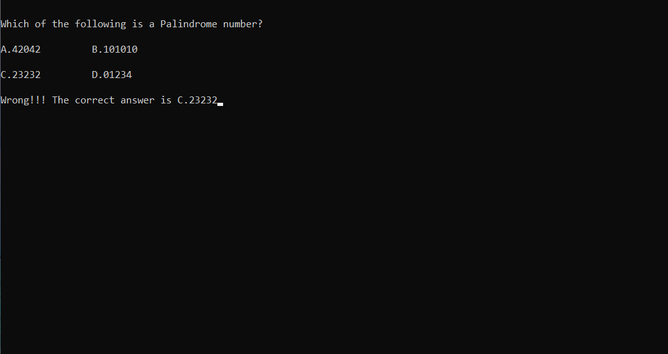

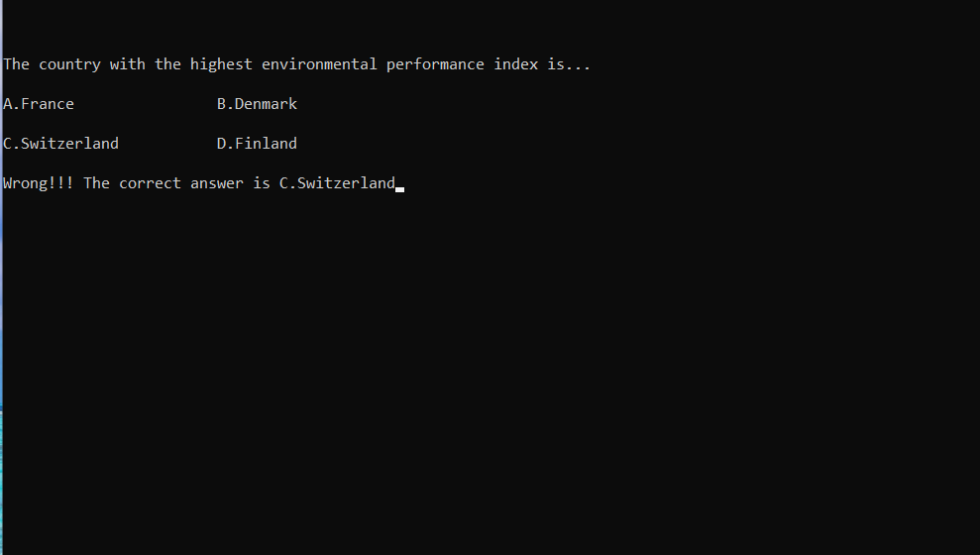

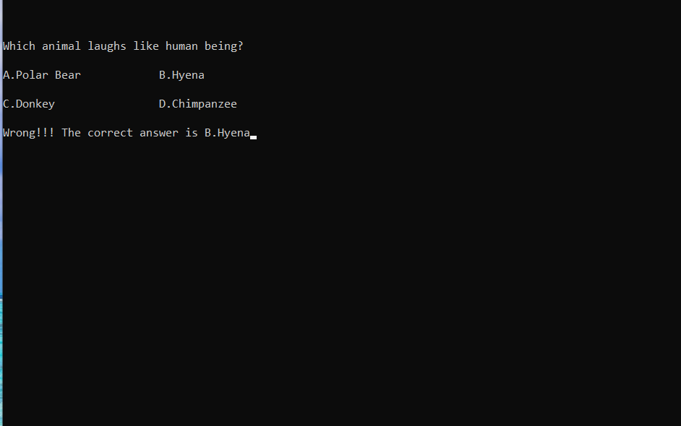

SPECIFICATION/REQUIREMENTS:
1] Hardware:
      - 1.7 GHz Pentium IV
      - 64 MB RAM
      - A Hard-drive space for storing questions.
2] Software:
- Operating System: Windows XP Service Pack 1
- Dev C++ Compiler

- TECHNOLOGY USED:

- C:
C (/siː/, as in the letter c) is a general-purpose, procedural computer programming language supporting structured programming, lexical variable scope, and recursion, with a static type system. By design, C provides constructs that map efficiently to typical machine instructions. It has found lasting use in applications previously coded in assembly language. Such applications include operating systems and various application software for computer architectures that range from supercomputers to PLCs and embedded systems.
  - Uses of C:
- C is highly portable and is used for scripting
system applications which form a major part
of Windows, UNIX, and Linux operating
system.
- C is a general-purpose programming language and can efficiently work on enterprise applications, games, graphics, and applications requiring calculations, etc.
- C language has a rich library which provides a number of built-in functions. It also offers dynamic memory allocation.
- C implements algorithms and data structures swiftly, facilitating faster computations in programs. This has enabled the use of C in applications requiring higher degrees of calculations like MATLAB and Mathematica.
Riding on these advantages, C became dominant and spread quickly beyond Bell Labs replacing many well-known languages of that time, such as ALGOL, B, PL/I, FORTRAN, etc. C language has become available on a very wide range of platforms, from embedded microcontrollers to supercomputers.

SCOPE OF THE PROJECT
It’s always interesting to see how people use question slides, sometimes amongst the content slides as knowledge check questions, sometimes as pre-test and sometimes to validate the learning through a post-test. In any of these scenarios, especially while using the question slides as knowledge check, we hit upon something known as Quiz Scope. What’s that by the way? We all know about it but may not be familiar with the exact terminology ‘Quiz Scope’.

CONCLUSION:
The Quiz Game is capable to handle number of Question record having all their information stored in the backend file.

REFERENCE:
- Web & Internet

